REVIVAL

**Recreating the sounds of the 60’s &70’s**

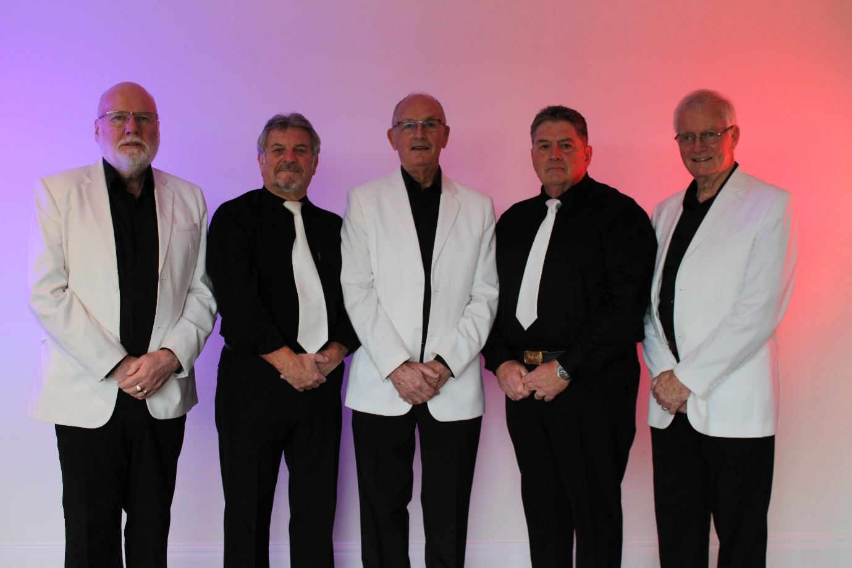

**www.revival-web.com**

**Overtype the date of the gig and any other information you wish to add here**

**APPEARING HERE**